- Purpose

The purpose of this procedure is to outline the steps necessary to clean the water recovery system and flush the main drain line feeding the plant. This should be done at a minimum of one time per week preferable after the weekly shutdown.

- Scope

This procedure applies to Water Recovery System at the Manufacturing Facility. This procedure shall be performed weekly.

- Responsibility

Maintenance Personnel, Lead Operator

- Safety Considerations

Safety glasses and appropriate safety apparel are to be worn at all times.

Safety is a condition of employment. Employees are not authorized to work in an unsafe manner and are prohibited from harming the environment of the facility or community.

- Materials/Equipment

N/A

6.0 Procedure

The Water Recovery System is designed to minimize the amount of usable plant water lost to the sewer system. Weekly cleaning is required in order for the system to work properly. Shift checks should be performed on the system to ensure that a process upset has not impacted the system which would require cleaning more frequently.
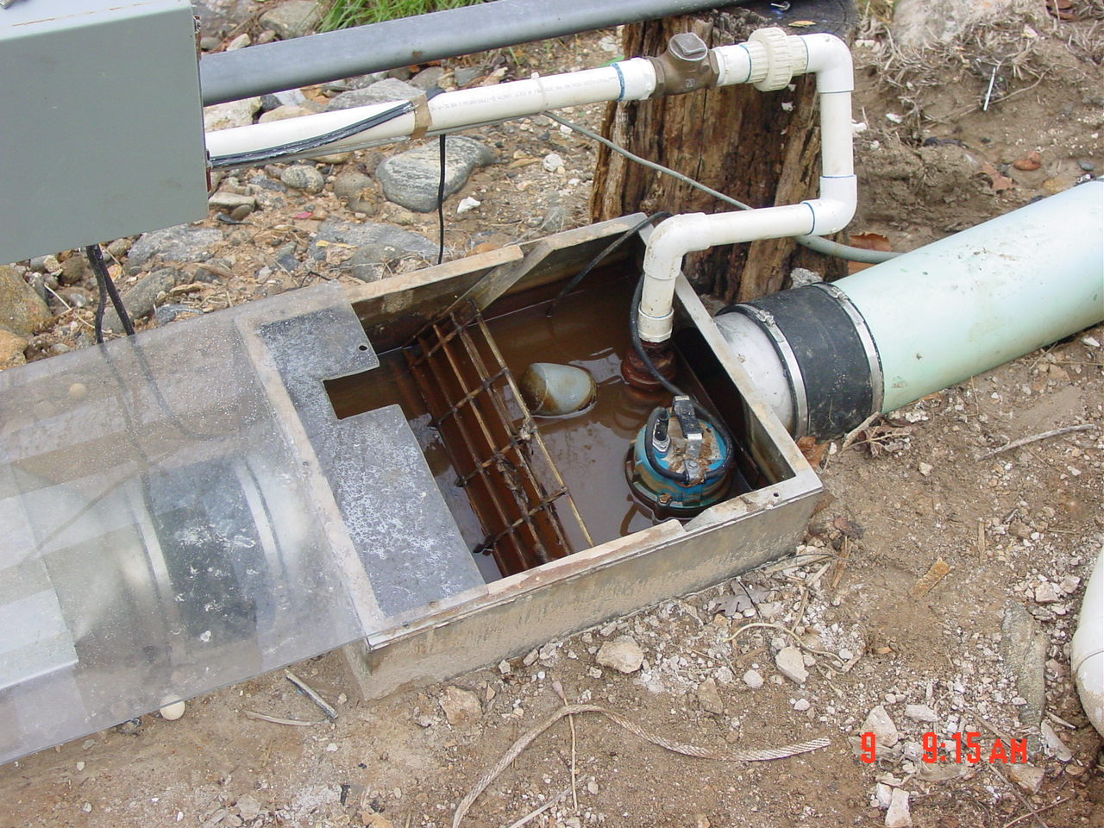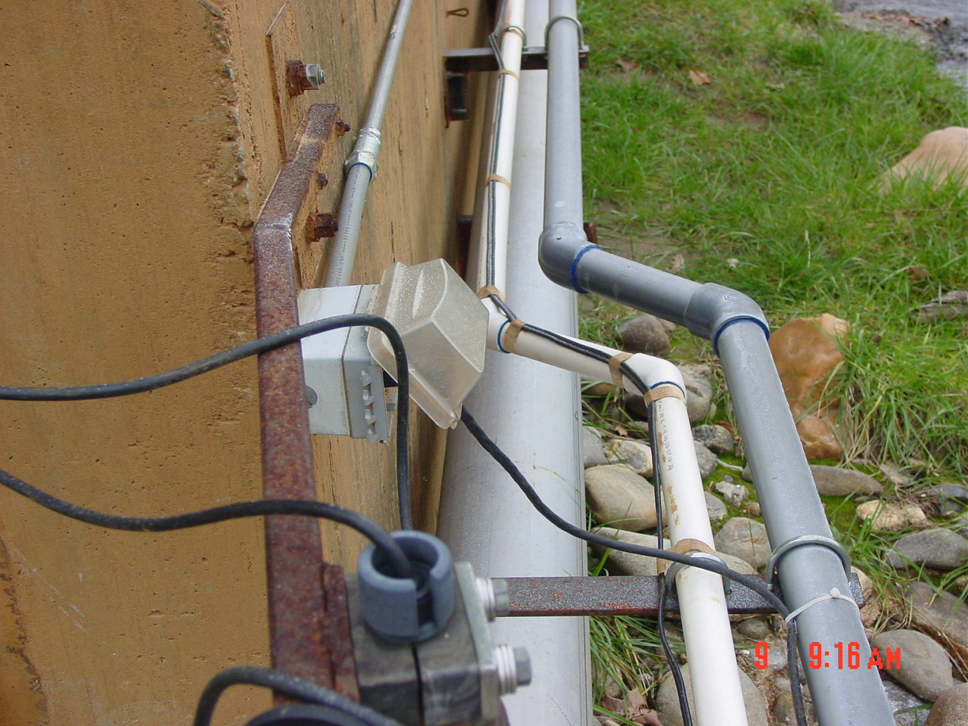
- Unplug the ditch pump (upper right photo), disconnect the union and remove the pump from operation in the ditch. (upper left photo)
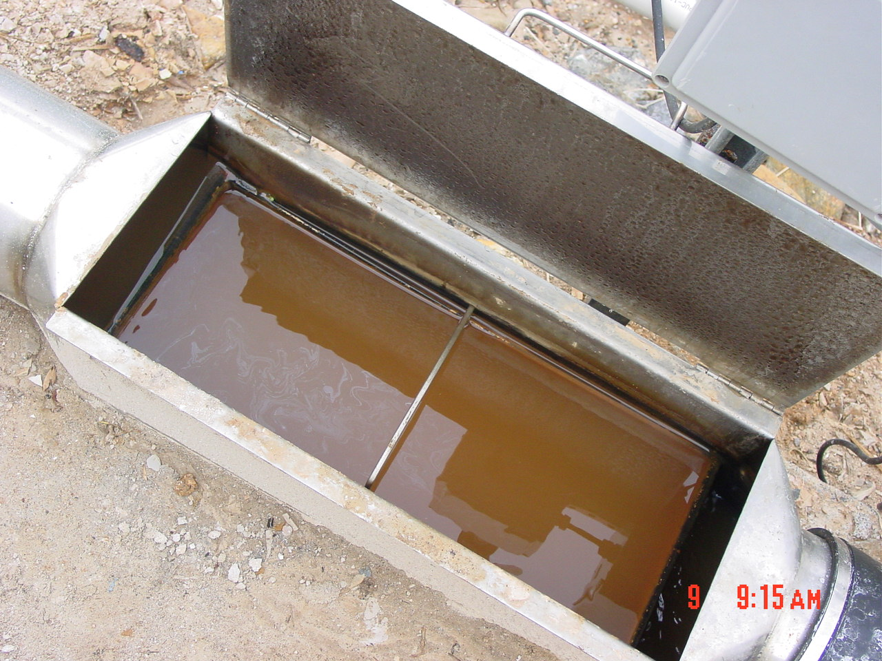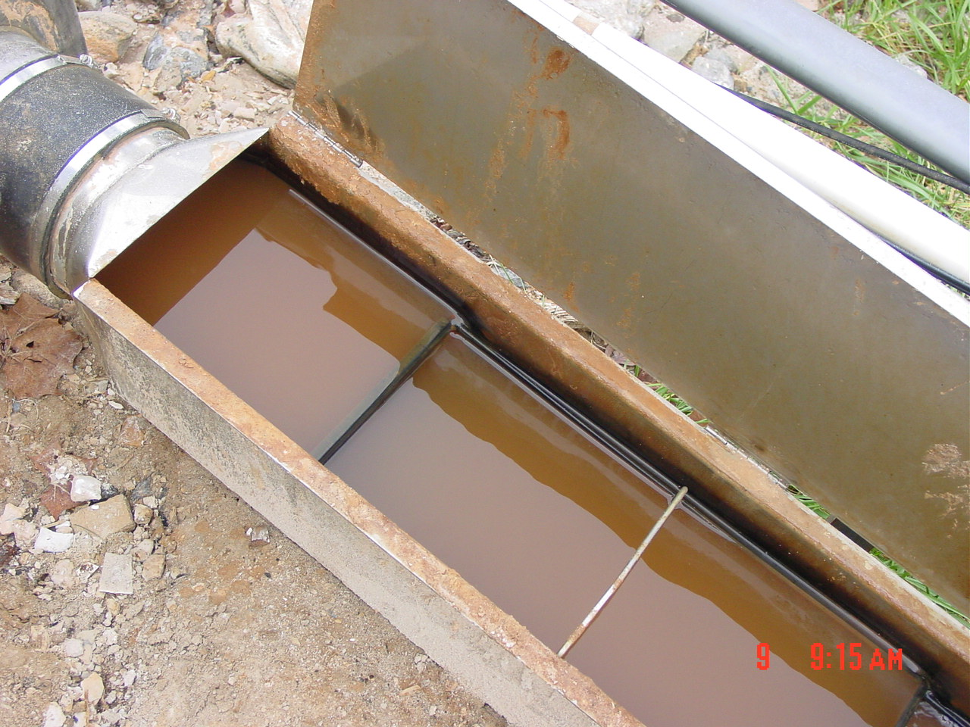
- Remove the slurry pans from the pipe and dispose of all material properly. Material should be taken to the disposal pit in the back of plant and disposed of properly. Material should not be dumped out on the creek bank where it could have negative impact.
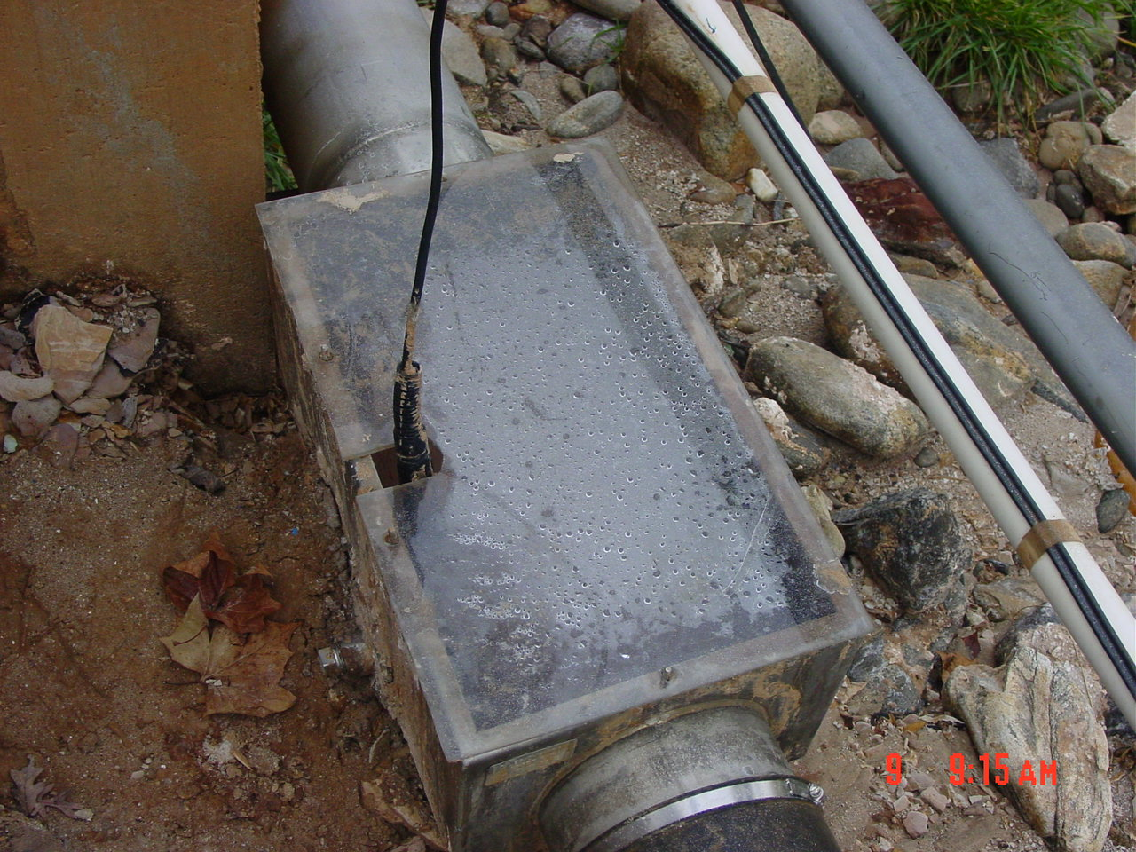
- Remove sewer probe from ditch and clean out this portion of ditch. Sewer probe must remain in a liquid solution at all times when removed from the ditch.
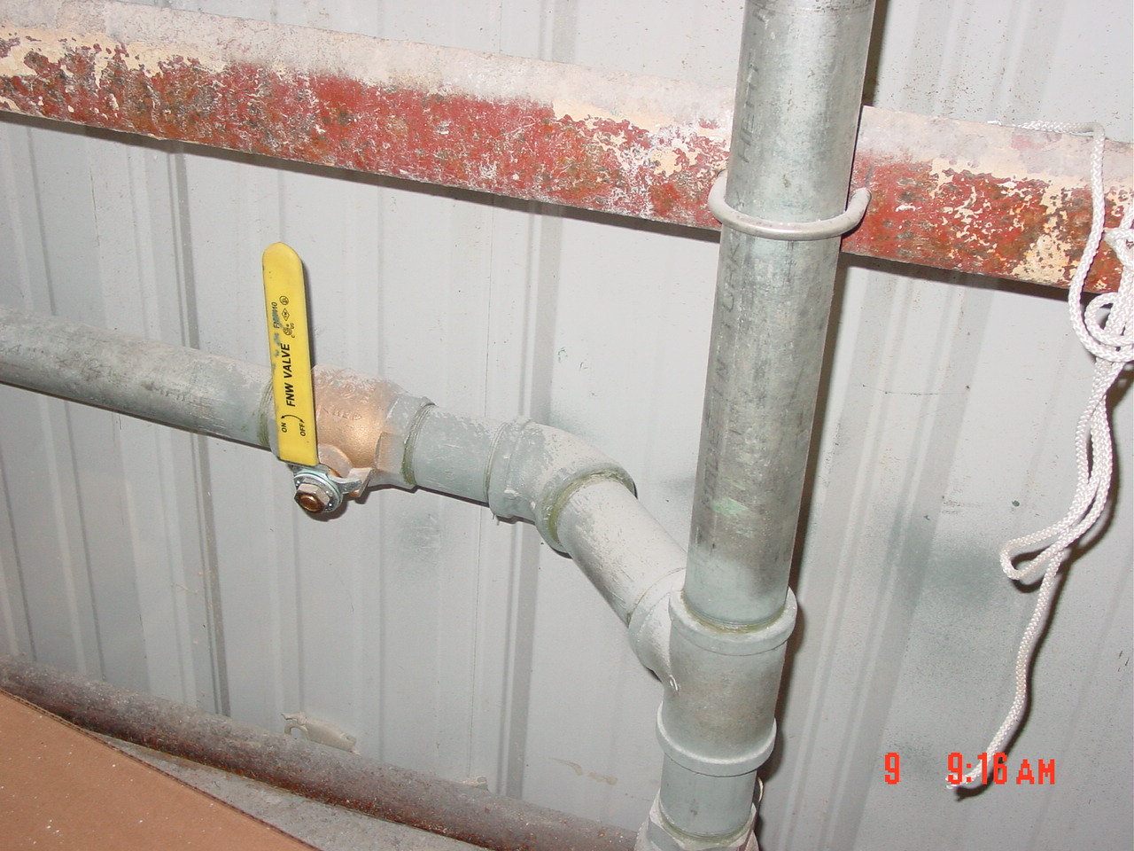
- Cut valve feeding flush line to the on position. This valve is located in the super sack tying area in the back of the plant.
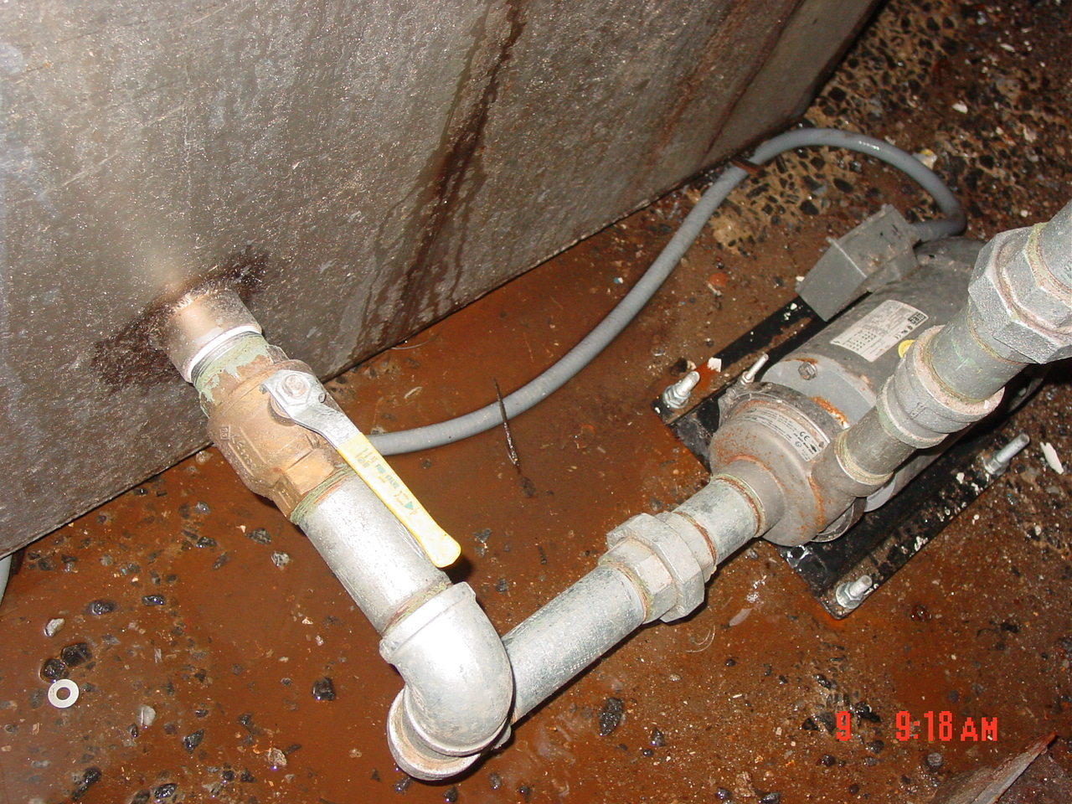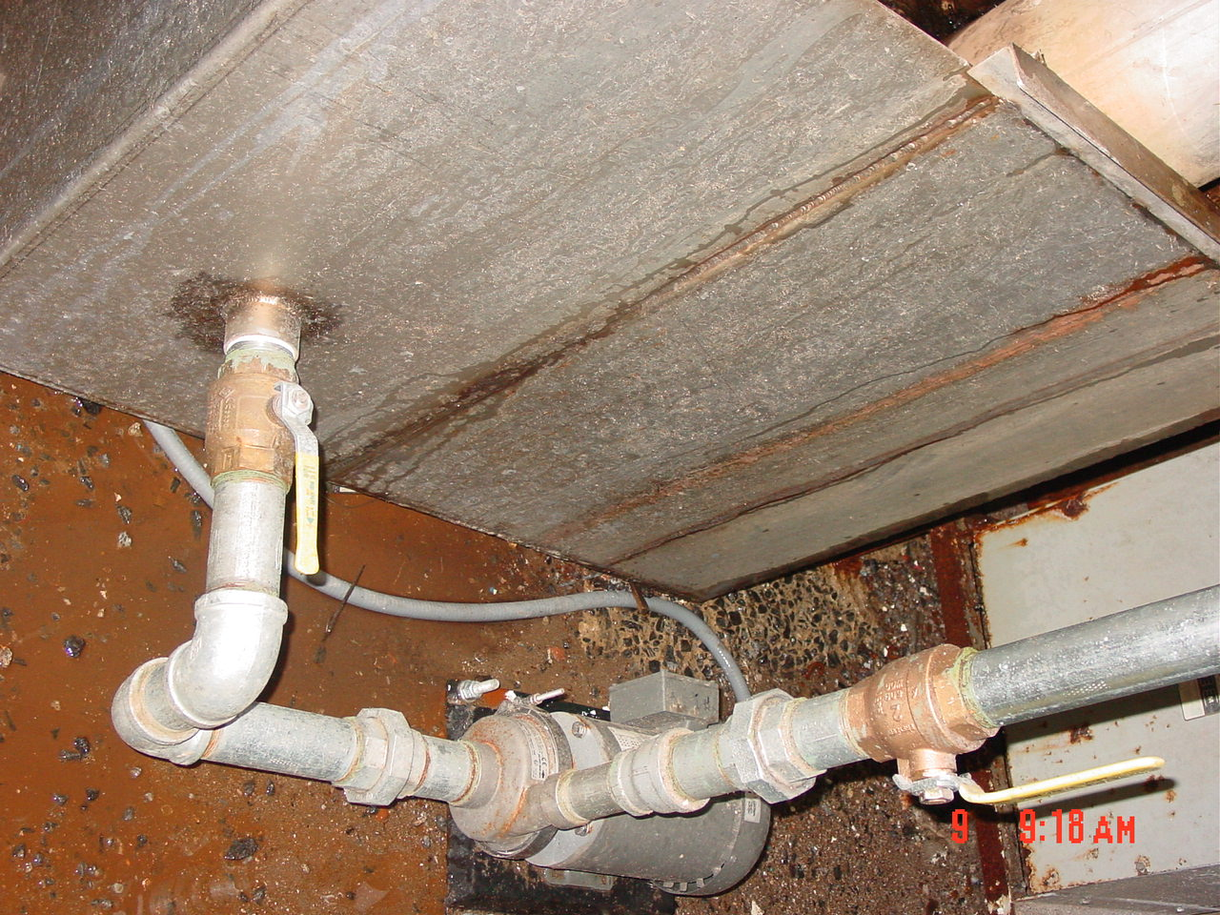
- Cut both valves (valve from hot well and valve on discharge side of pump) to the on position from the hot well that is fed from crystallizer #1 and #2.
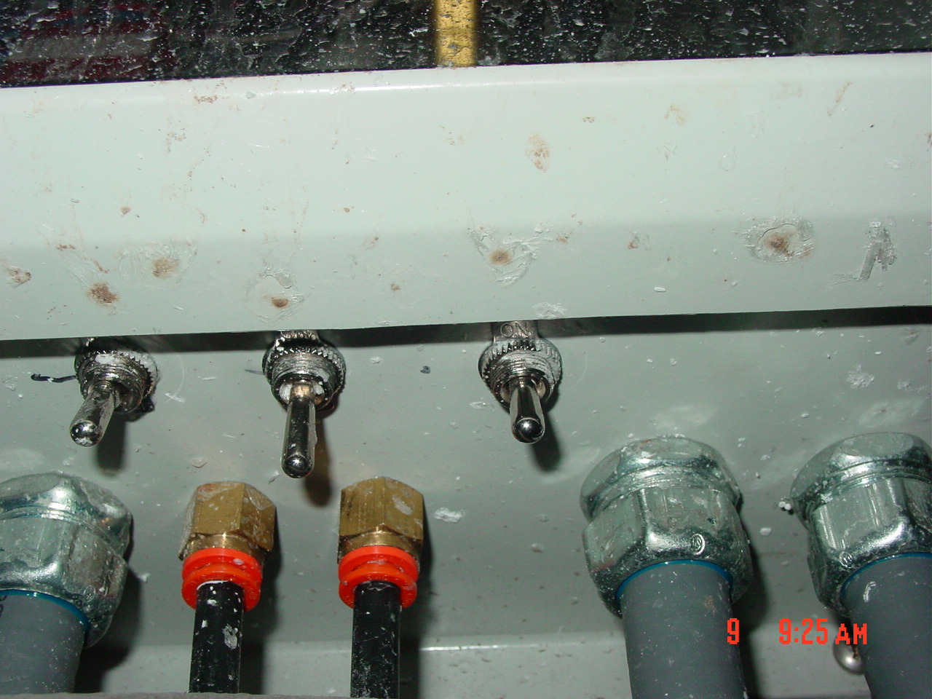
- Cut pump on using the switch underneath control panel located next to the hot well. (Facing panel it is switch to the far right.)

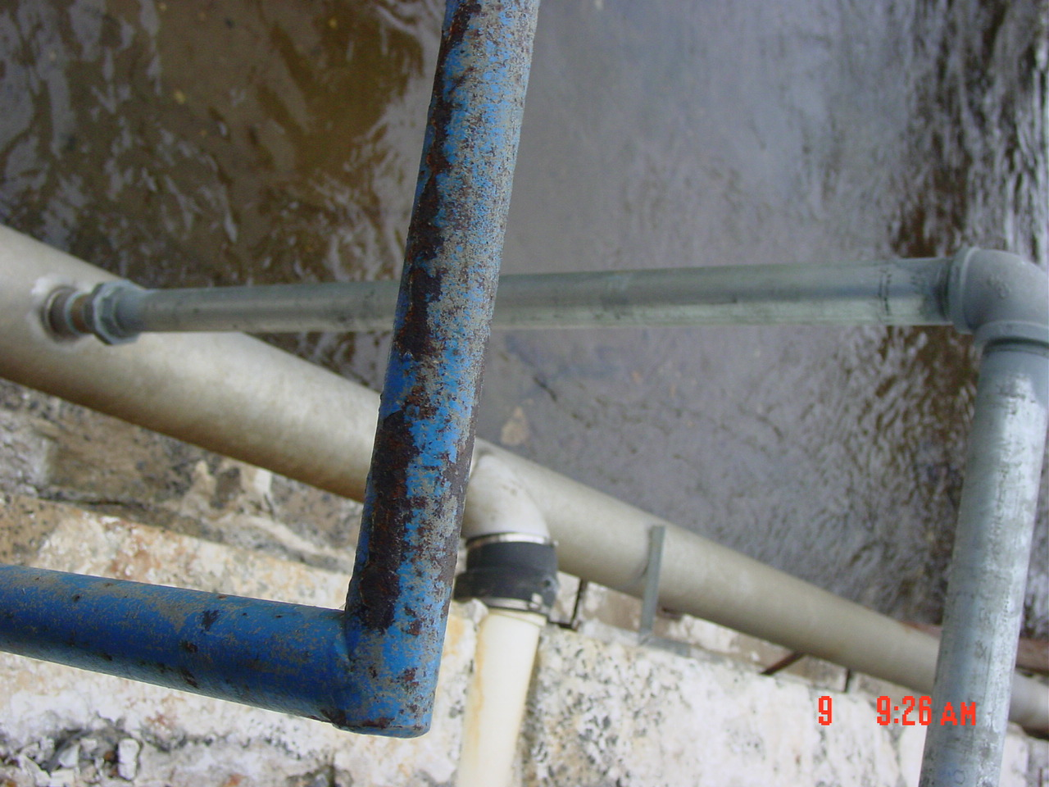
- Flush line for at least 20 minutes to ensure that maximum amount of flush occurs. Reverse steps to place system back in production and confirm that system is working properly.
- Reference Documents

N/A

- Change Information

New Document

